Aviel Resnick

Exercise 13.1

1. What keeps a recursive definition from being circular?

1. Recursive definitions have base cases (values), unlike circular definitions

2. What are the two parts of any recursive method?

1. The preconditions, and the recursive portion.

3. Why is recursion more expensive than iteration?

1. Recursion is more expensive because repetitive method calls take more memory than incrementing an iterative solution.

4. What are the benefits of using recursion?

1. For certain problems, the recursive solution is actually easier, and in a lot of cases it allows the programmer to reuse code (for more efficiency)

5. Consider the following definition of the method raise, which raises a given number to a given exponent:

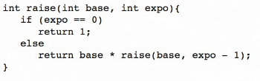

Draw a trace of the complete execution of raise(2, 5).

(2,5) = 2 \* (2,4) = 4 \* (2,3) = 8 \* (2,2) = 16 \* (2,1) = 32

6. Consider the following method:

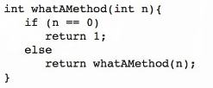

What happens during the execution of whatAMethod(3)?

StackOverflow Exception, because there will never be a change to n, and unless n is 0, it will recurse infinitely.